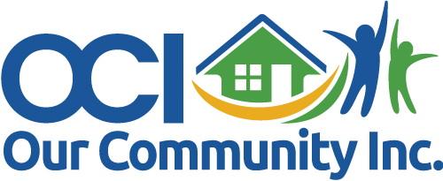

**PUBLIC NOTICE**

**August 14, 2024**

Our Community, Inc. (OCI) Board of Directors will conduct a

Board Meeting

**Wednesday, August 21, 2024 at 10:00 a.m.**

at Our Community Housing and Enrichment Center (OCHEC)

located at 1001 Montana Street Dothan, AL 36303

**In-person** and **Virtually via Zoom.**

* **ZOOM Meeting ID: 883-098-6433**
* [**https://us02web.zoom.us/j/8830986433**](https://us02web.zoom.us/j/8830986433)

**AGENDA**

**08-21-2024**

Call To Order

Approve August 21, 2024 Agenda

Approve June 18, 2024 Board Meeting Minutes

**NEW BUSINESS:**

Change Monthly Board Meeting to Quarterly

**PRESIDENT UPDATES:**

Comments

Adjourn